

**DOCUMENTATION**

**NASA Astronomy Picture of the Day**

* SRIKANTH S

Overview

The aim of this project is to create a iOS app that helps with displaying NASA’s “Astronomy Picture of the Day”.

The project uses application architecture of MVVM design pattern. Model-View-ViewModel is a software design pattern that is structured to separate program logic and user interface controls.

Basic features of this app

* Allow users to search for the picture for a date of their choice
* Allow users to add picture to favourite list and delete from favourite list
* Display date, explanation, title and picture of the day
* Dark mode support
* App should handle different screen sizes, orientations

How To Build

* This is an iOS App, so it needs XCODE to run this project

Frameworks

* Core data is used to manage data for this application.
  + It is the framework provided by Apple to save, track, filter, and modify the data within the iOS applications.
* Swiftui is used to build this project
  + SwiftUI is a user interface toolkit that lets us design apps in a declarative way

ViewController

This controller is used to fetch data from Nasa api and convert this fetched Jason data to user data using json decoder.

This class uses observableobject protocol which means when the data in the model changes, any views that are using this model will automatically update and reflect those changes.

We’re also using the published property wrapper to make property observable.

Ex: **class** NetworkManager:ObservableObject{

@Published **var** apod:APODModel=APODModel

… })

In this we are using URLsession.shared.datatask() method provided by URLSession which is used to fetch data from remote server using url.

Ex: **let**ttask **=** URLSession**.**shared**.**dataTask(with:request)

Using Jason decoder to parse json data and convert it into instance of APOD model.

Ex: **let** apod = JSONDecoder().decode(APODModel,from:data)

Using DispatchQueue.main.async to make task run asynchronously on main thread.

Ex:d. DispatchQueue.main.async{

**self.**apod=apod

}{

Views

APODView –

This view is the main page of our Nasa app. It is used to display astronomy picture of the day, title and description of the image. This view also take date input from datepicker and display astronomy picture of that particular date. Also favourite feature is added where user can add their favourite apod in favourite list on clicking favourite button.

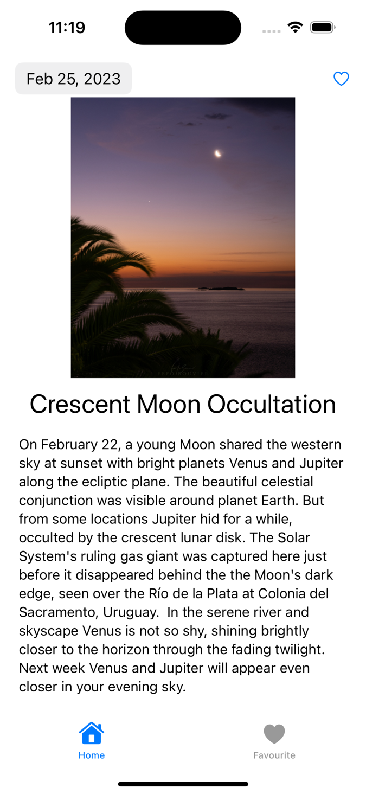

FavouriteView –

This view is responsible for displaying favourite list that is added by the user. Delete is also added in this feature where user can swipe left to delete data from favourite list and on clicking any particular list it will redirect to detailed favourite list.

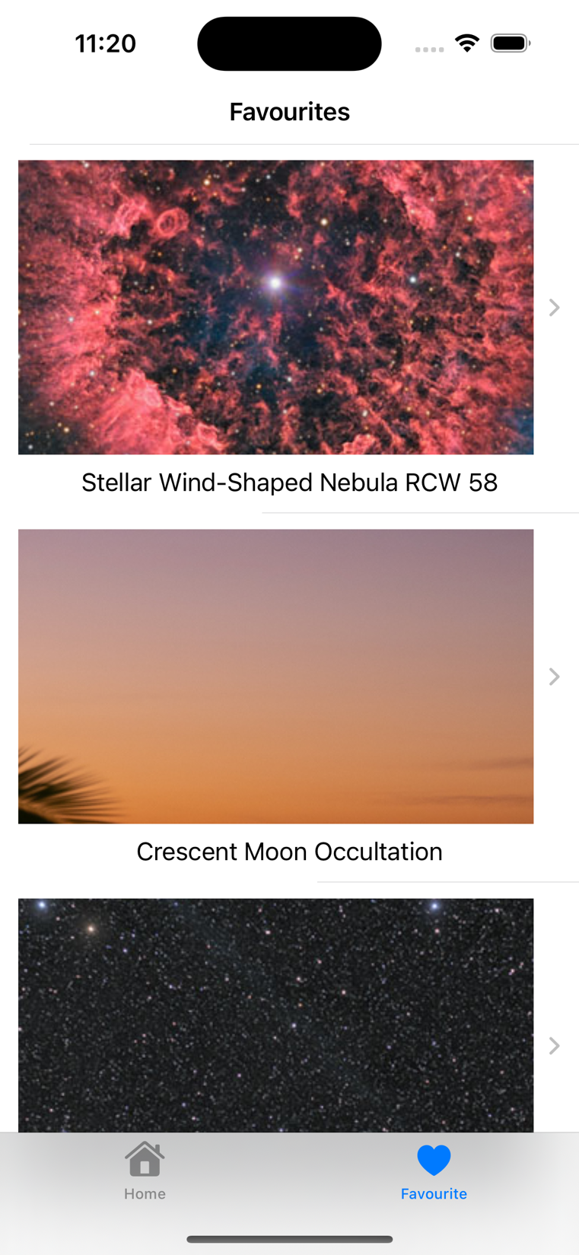

DetailedFavouriteView –

In this view user can see a complete details of the particular astronomy picture which is selected from favourite view list.

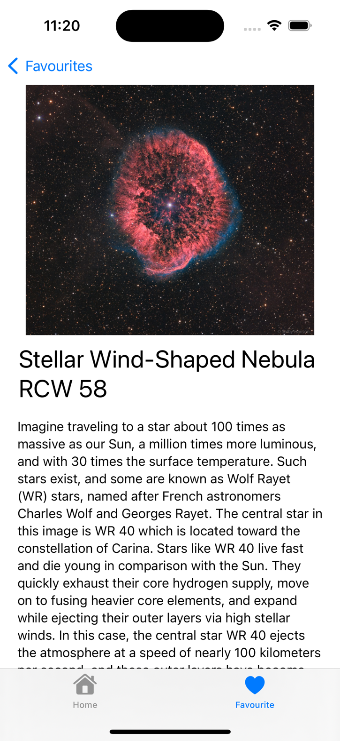

Dark Mode Support:

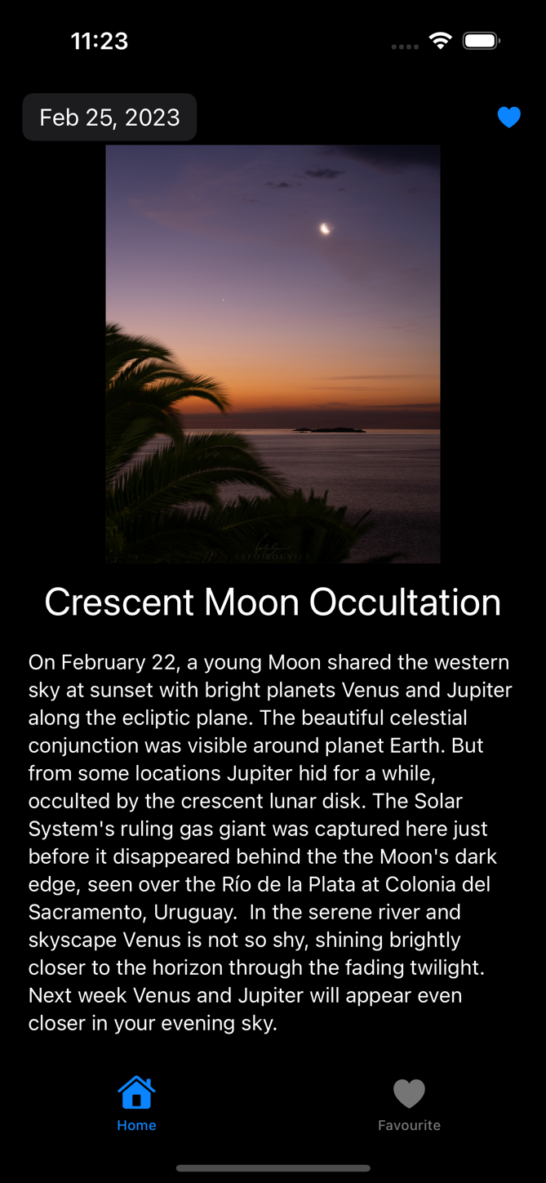

**THANK YOU**